A1: Initial Business Case - Documentation

|  |  |
| --- | --- |
| **Project Title** | Smartphone Meter Reading System |
| **Group Members** | Vishal Mishra                      (vm816@uowmail.edu.au)  Jingwang Teh                       (jt957@uowmail.edu.au)  Christopher Tan Wei Ming  (cwmt957@uowmail.edu.au)  Olawale Adeyinka Adu       (oaa692@uowmail.edu.au)  Yuxin Deng                          (yd536@uowmail.edu.au) |
| **Client** | N/A |
| **Supervisor** | Dr. Koren Ward (koren@uow.edu.au) |
| **Initial Problem Description** | The aim of this project is to develop an electricity, gas or water meter reading system that involves the use of a smartphone to take a photo of the meter and image processing software to extract the meter reading from the photo of the meter.  The smartphone also uses its GPS unit and a customer address (GPS) database to look up which customer’s meter has just been read, and then enters the customer’s meter reading into the database.  This system would significantly reduce the amount of work involved in reading meters. A customer version (smartphone app) could also be developed so that a customer could use his or her smartphone to read the meter and instantly see their current consumption and billing information based on the information in the image and the billing database.  There are two ways the system could be developed. One way is the have the smart phone send the photo of the meter to a server where the image processing and data logging is done. The other way involves processing the photo with the smart phone and sending the extracted meter reading to the server for entry into the database. |
| **Meeting Details** | Thursday, 10th March 2017, 12:30pm at Library Group Study Room 4.  (Initial Meeting with Supervisor) Friday, 17th March 2017, 12:30pm at Building 3 – Front Sitting Area.  Friday 24th March 2017, 2:30pm at Building 3 – Front Sitting Area. |

Table of Contents

1.0 Scope Management 3

1.1 Scope Statement 3

1.2 Work Breakdown Structure 4

1.3 Scope Change Control 5

2.0 Market Analysis 5

3.0 Time and Quality Management 7

3.1 Draft Project Schedule 7

3.2 Schedule Performance Tracking 11

3.3 Project Success Criteria (SMART) 15

4.0 Risk Management 16

5.0 Initial Identification of Skills 22

5.1 Project Description 22

5.2 Project Skills Requirement 22

5.3 Student skills and Responsibilities 24

Appendix 27

Stakeholder Analysis 28

Project Charter 31

Group Meeting Agendas and Minutes 33

# 1.0 Scope Management

## 1.1 Scope Statement

Our group has chosen the Smartphone Meter Reading System as part of our CSCI 321 Project. The aim of this project is to develop an electricity, gas or water meter reading system that involves the use of a smartphone to take a photo of the meter and image processing software to extract the meter reading from the photo of the meter which will enable the user to capture snap shots of their meters and get the readings as fast as possible. The app will be available in two versions. One on the customer and another by the retailer/ meter supplier. On the customer site, they will be allowed to read the meter at an instance and see their current consumption and billing information based on the information in the image and the billing database. On the other hand, the retailer version of the app is slightly different from the users. It will be faster in processing image and removing all manual work such as entering the address of the customer whose meter is being read. This can be done by using the smartphone’s GPS technology to pinpoint the current location of the user. After that it will store all the information on the customer’s meter reading into the database. We will be developing this project on the Android platform. However, if time permits we will be extending to the development of iOS app for apple devices.

Nowadays, the cost of hiring a meter reader per year is $50,000 which is a lot for company. The current process of meter reading is currently expensive and inefficient as energy companies are required to employ a high number of workers to read energy meters manually, making it prone to human errors and slow without the aid of technology. Previously, meter reading companies have tried to solve this problem by implementing a smart meter reader system whereby they install a new meter with a sim card which is owned by other telco companies. The problem with this is that the companies who owns the sim card will want to take advantage on the meter reading companies because the smart meter solely depends on the sim card for it to work. Moreover, smart meter charges at a higher rate during peak hours. Because of this, customers in Australia has since stopped using smart meter due to the high cost that are being billed to them during peak hours.

Our project aims to improve the efficiency and accuracy of the meter reading process which will help the company cut their cost in the long term. This system would significantly reduce the amount of work involved in reading meters. By using our technology, meter readers will have a 100% accurate reading and can accomplish their task at a faster rate than before. On the other hand, a customer could use his or her smart phone to read the meter and instantly see their current consumption and billing information based on the information in the image and the billing database. Our system will be developed by having the smart phone to process the photo with the smart phone and sending the extracted meter reading to the server for entry into the database. Our team will be developing a web interface with analytics that will provide customers with information regarding the current usage and forecasted usage of the resources.

## 1.2 Work Breakdown Structure

## 1.3 Scope Change Control

**Change Control**

|  |  |  |  |  |  |  |  |  |  |
| --- | --- | --- | --- | --- | --- | --- | --- | --- | --- |
| Control | Status | Description | Title | Desc. | Proposer | Date Logged | Complexity (H,M,L) | Impact Description | Change Category |
|  |  |  |  |  |  |  |  |  |  |
|  |  |  |  |  |  |  |  |  |  |
|  |  |  |  |  |  |  |  |  |  |
|  |  |  |  |  |  |  |  |  |  |

**Scope Control**

|  |  |  |
| --- | --- | --- |
| Inputs | Tools & Techniques | Outputs |
|  |  |  |
|  |  |  |
|  |  |  |
|  |  |  |

# 2.0 Market Analysis

We determined the characteristics unique to our market and analysed the information, the information will help us make decisions for our project/business. By conducting this market analysis, we were able to gather valuable data which will help us determine the appropriate pricing for this product, it will help us get to know our customers better and it will assist in figuring out what our competitors’ vulnerabilities are. These are the objectives of our market plan:

**1.    Smartphone Meter Reading Industry description and Outlook**  
This industry is a growing one. There are 4 major companies which provide this service and none of them is in Australia. The major players in the industry are European and US companies (SMARTPHONE METER READING LLC, Pixolus GmbH, EnergyElephant, and MUNIBILLING). They all have one thing in common, they use all use an image processing software or library in the development of their application. Integrating their products in the utility system over there in Europe and America is a bit easier, because of the fact that there are so many utility companies out there and they are all striving to make their service stand out from competitors, so they take any advantage they see in order to get ahead of competitors. In Australia here, it is not popular, the farthest most utility companies have gone here is embed a hardware to the meter that monitors it and records data that will be take either monthly or in 3 months interval, a system which is still not efficient and prone to many errors and redundancies.

**2.    Target Market**

Our target market will be focusing on anyone who pays utility bills and energy companies. Which means every household in the neighbourhood in Australia and in fact the world. This will include a student trying to save as much money as possible on bills, a family that wants to cut back on the amount of energy or water consumption in the house or even a company that has a spike in utility bills every month but doesn’t know what the cause in spike is. The market size of this product is really everyone and it could potentially become one of the most popular/used application be it locally or internationally because people want to save as much as possible on utility bills or they want to know how much energy or water they consume and energy companies will save a lot of time if consumers are able to have a streamlined process and be more in touch with consumers.  
  
**3.    Competitive Analysis**  
We had to dissect our competitors and see what we are up against, but not only that, we had to know their weaknesses so we could learn from their shortcomings. We needed to know if the customers are being underserved or how they are being served. The smartphone meter reader industry is non-existent in Australia, there are no companies that provide that service, which gives us the advantage to create a niche in Australia. Our secondary competitors that could impact our business would be the energy/water corporations that have employees that go out to do a manual reading of the utility meter. The other competitors we have are our American and European competitors which have been in the smartphone meter reading business for a while and have made significant progress with the utility companies in their respective countries.  
  
**4.    Barriers to entry**  
Before we can make an entrance to the utility market, we have to make sure we know the constraints we face in the effort of making entry. In order to do so, we have to fully study and understand these.

•    ECONOMIES OF SCALE: When we enter the market we can either come on a large scale, which will risk a reaction from incumbents (other energy corporations coming out with their own products or applications) or come on a small scale (forcing a cost disadvantage)

•    PRODUCT DIFFERENTIATION: Incumbents (energy corporations and consumers) have consumer loyalties and brand identification. This fact will force us entrants to spend heavily to overcome these loyalties. With features in our application which provide a better, faster and effective way of dealing with utilities, consumers would prefer an energy corporation with our application rather than not.

•    CAPITAL REQUIREMENTS: This project requires little or no capital requirement, just a lot of Research and development.

•    SWITCHING COSTS: There’s no cost required for consumers switching to our application, for energy corporations, they face a one-time cost when switching to our product, they need to back the rollout of the product to their customers and handle the advertisement or publicity of the product too which could cost a bit

**Characteristics of our product**

These are the characteristics and features of our product that differentiates it from other products on the market, these characteristics improve on existing products, and ones that fill a currently unfilled need. Our features will include:

* **GPS Integration**

To prove that the meter reader was at the correct location when the meter data was collected, our application will capture GPS coordinates automatically for every meter reading. This will also help resolve customer disputes, optimize reader performance and aid in locating meters and other utility field assets.

* **Ease of Use**

All our customer needs to know is how to take a photo with their smart phone, our application will automatically use it’s image library software to process the image and send the contained data to the servers.

* **Accuracy**

Regularly reading and maintaining utility meters is very time-consuming. Typing in numbers with a special device or even writing them down on a piece of paper is not only a lot of work but it is also very prone to errors. With our application, reading and recording meters is not only faster, its also very accurate and not prone to any human error.

* **Better Consumer Relations**

When/If utility companies integrate this product into their system and distributes it to their customers, customers will be able to track the whole process of their energy consumption, using the application, customers will feel more involved in the process of their energy consumption. They’ll be able to read their meters themselves and therefore be able to control their energy consumption which will bring energy efficiency to a more personal level.

# 3.0 Time and Quality Management

## 3.1 Draft Project Schedule

**Gantt Chart**

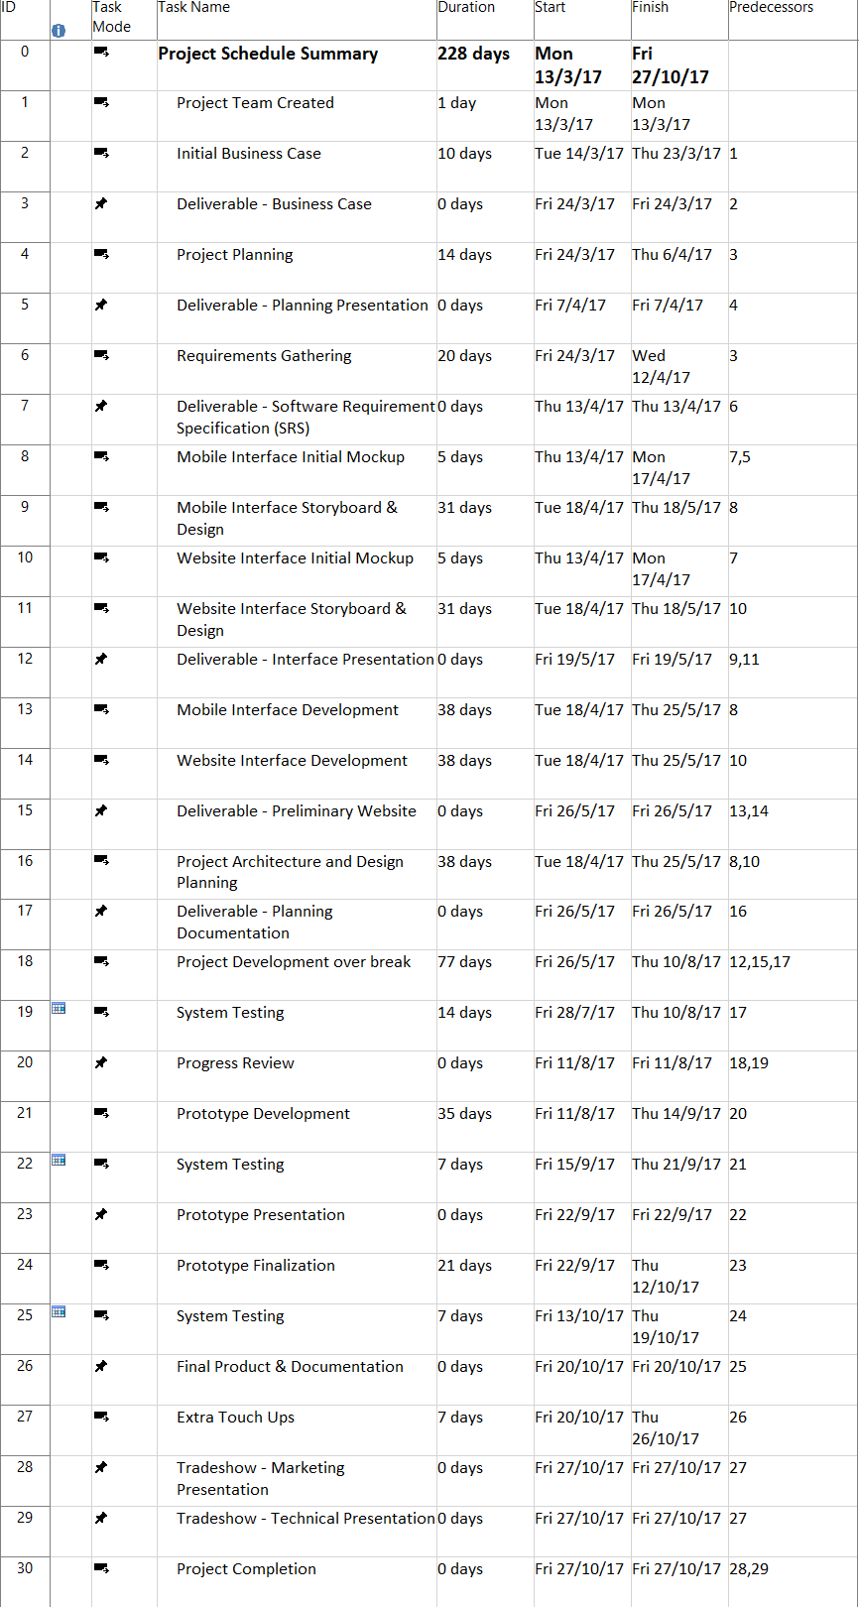

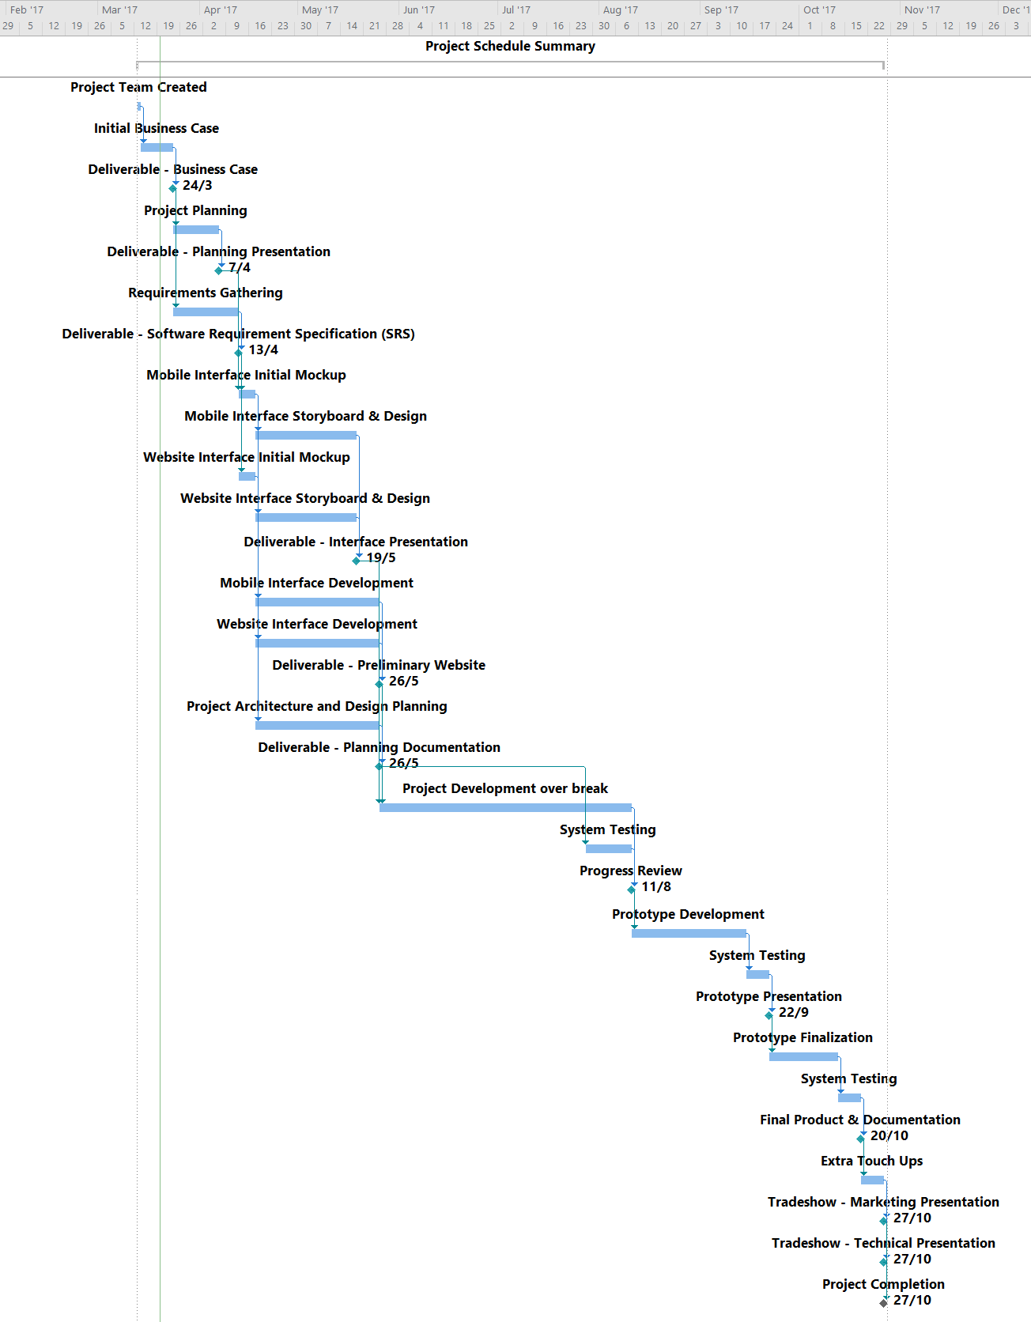

**Project Network Diagram**

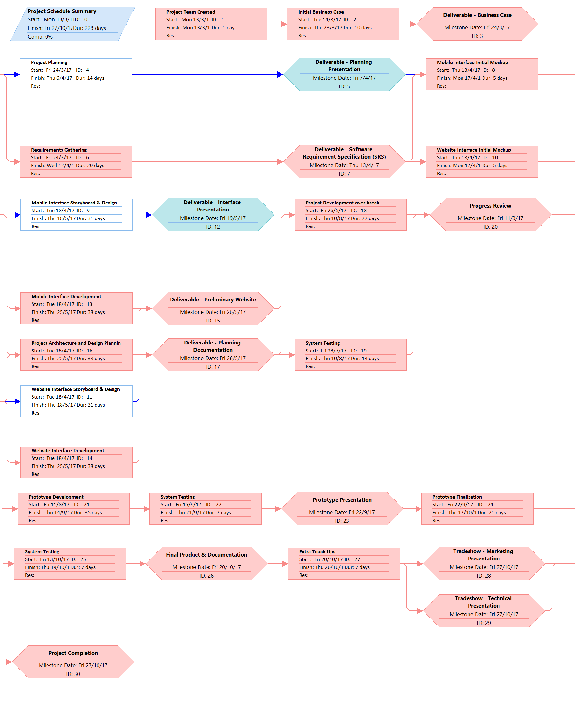

**Critical Path Analysis**

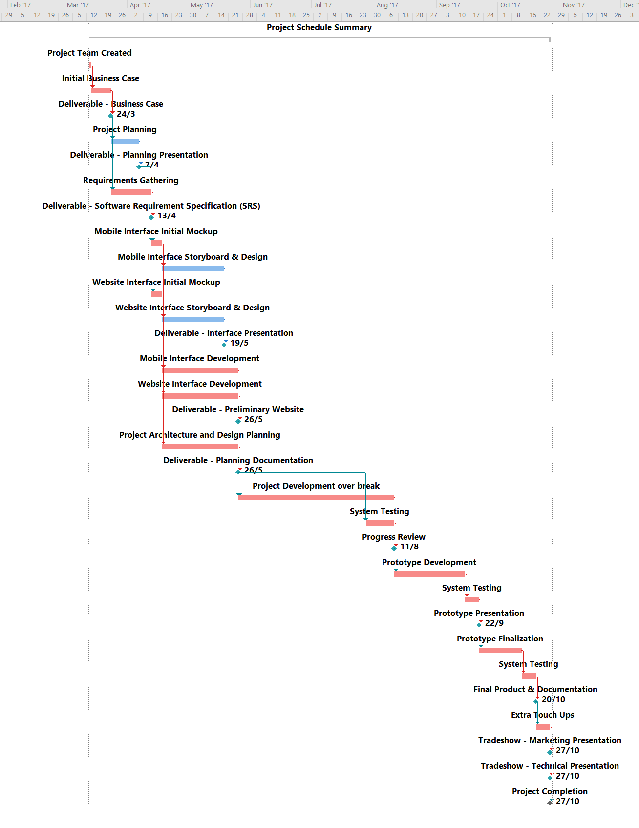

## 3.2 Schedule Performance Tracking

**Project Schedule Metrics**

|  |  |  |
| --- | --- | --- |
| **Code** | **Score** | **Action** |
| Red | Far behind Schedule (x > 3) | 1. Emergency team meeting  2. Report to supervisor  3. Tasks rescheduling |
| Yellow | Slightly behind Schedule (1 <= x < 3) | 1. Find out reason for delay  2. Re-estimate tasks  3. Allocate more time in week for task. |
| Green | On Time (0 <= x < 1) | 1. No Actions required. |
| White | Ahead of Schedule (x < 0) | 1. Review tasks  2. Improve existing application  3. Implement stretch-goals |

X = actual duration – estimated duration

**Checklist and Task Benchmarking**

|  |  |  |  |  |  |
| --- | --- | --- | --- | --- | --- |
| **Current Date (Last-Updated):** 23th March 2017 | | | | | |
| **Project Tasks** | **Started?** | **Completed%** | **Estimated Duration** | **Actual Duration** | **Finish Variance** |
| Initial Business Case | ✔ | 100% | 10 days | 10 days | 0 days |
| Project Planning | ✖ | 0% | 14 days | - | - |
| Requirements Gathering | ✖ | 0% | 20 days | - | - |
| Mobile Interface Initial Mockup | ✖ | 0% | 5 days | - | - |
| Mobile Interface Storyboard & Design | ✖ | 0% | 31 days | - | - |
| Website Interface Initial Mockup | ✖ | 0% | 5 days | - | - |
| Website Interface Storyboard & Design | ✖ | 0% | 31 days | - | - |
| Mobile Interface Development | ✖ | 0% | 38 days | - | - |
| Website Interface Development | ✖ | 0% | 38 days | - | - |
| Project Architecture and Design Planning | ✖ | 0% | 38 days | - | - |
| Prototype Development | ✖ | 0% | 35 days | - | - |
| Product Finalization & Documentation | ✖ | 0% | 21 days | - | - |

**Quality Metrics**

|  |  |  |
| --- | --- | --- |
| **Quality Checks** | **Description** | **Value** |
| Leads Check | Number of tasks completed ahead of schedule / Total Tasks | - |
| Lags Check | Number of tasks completed after schedule / Total Tasks | - |
| Critical Path Test Check | Critical Path Delays in Days | - |
| High Duration Check | Number of tasks with duration of more than 40 days | - |
| Logic Check | Number of tasks with missing predecessor or successor | - |

**Cost of Quality**

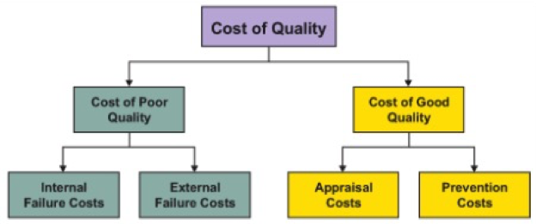

The general perception is higher quality needs higher cost, in order to guarantee our project success, so we decide to introduce cost of quality management. Because of we are a small project team, so the 6 sigma is not fully applicable for this project. Thus, we chose to use the basic cost of quality management. First we must identify the prevention costs and appraisal costs for good quality, and then we should identify internal and external failure costs and identify the level of costs, then we can decide to make cost in significant tasks.

Most of the costs should be spent on prevention, as it is more effective in the long run, which would be done through thorough testing and rework process, so we think the relationship of each part should be:

***Prevention costs > Appraisal costs > Internal failure costs > External failure costs***

|  |  |  |  |
| --- | --- | --- | --- |
| **Cost area** | | **Description** | **Examples** |
| Costs of good Quality | Prevention costs | all activities that are designed to prevent poor quality appear in products or service | Quality planning  Systems development and management  Error proofing  Capability evaluations  Quality improvement team meetings  Quality improvement projects  Quality education and training |
| Appraisal costs | control products and services to ensure a high quality level in all stages | Checking and testing purchased goods and services  In-process and final inspection/test  Field testing  Product, process or service audits  Calibration of measuring and test equipment |
| Costs of poor Quality | Internal failure costs | Caused by products or service not follow the requirements or customer needs(before delivery to external customers) | Rework  Delays  Re-designing  Shortages  Failure analysis  Re-testing  Downtime  Lack of flexibility and adaptability |
| External failure costs | Caused by efforts or deficiencies found by external customer(After delivery) | Complaints  Repairing goods and redoing services  Warranties  Customers’ bad will |

|  |  |  |  |  |
| --- | --- | --- | --- | --- |
| **No.** | **Project Tasks** | **Potential problems** | **Costs** | **Level** |
| 1 | Initial Business Case | Rework and Delays  Capability evaluations | prevention costs  Internal failure costs | **1** |
| 2 | Project Planning | Rework and Delays  Capability evaluations | prevention costs  Internal failure costs | **1** |
| 3 | Requirements Gathering | Rework and Delays  Capability evaluations  Fail analysis | prevention costs  Internal failure costs | **2** |
| 4 | Mobile Interface Initial Mockup | Rework and Delays  Quality planning  Quality improvement team meetings | prevention costs  Internal failure costs | **3** |
| 5 | Mobile Interface Storyboard & Design | Rework and Delays  Re-designing  In-process testing | prevention costs  appraisal costs  Internal failure costs | **4** |
| 6 | Website Interface Initial Mockup | Rework and Delays  Re-designing  In-process testing | prevention costs  appraisal costs  Internal failure costs | **3** |
| 7 | Website Interface Storyboard & Design | Rework and Delays  Re-designing  In-process | prevention costs  appraisal costs  Internal failure costs | **4** |
| 8 | Mobile Interface Development | Rework and Delays  Re-designing  In-process testing | prevention costs  appraisal costs  Internal failure costs | **5** |
| 9 | Website Interface Development | Rework and Delays  Re-designing  In-process testing | prevention costs  appraisal costs  Internal failure costs | **5** |
| 10 | Project Architecture and Design Planning | Rework and Delays  Re-designing  In-process testing | prevention costs  appraisal costs  Internal failure costs | **6** |
| 11 | Prototype Development | Rework and Delays  Re-designing  Final testing | prevention costs  appraisal costs  Internal failure costs | **6** |
| 12 | Product Finalization & Documentation | Rework and Delays  Customers’ bad will  Field testing | appraisal costs  Internal failure costs  External failure costs | **3** |

|  |  |  |  |  |  |  |
| --- | --- | --- | --- | --- | --- | --- |
| **Level** | **1** | **2** | **3** | **4** | **5** | **6** |
| **Significance ‬** | **Lower** | **Low** | **Medium** | **High** | **Higher** | **Extremely** |

## 3.3 Project Success Criteria (SMART)

By 20 October 2017, implement the smartphone meter reading android application, and website application with resource analytics, and compile all product documentation developed at each project milestones, by adhering to assessment guidelines, requirements requested by client and supervisor, and international standards, and utilizing the currently available computer vision technology and web analytic presentation tools, in order to improve the efficiency of reading meter measurements for employees who are required to repeat the same task for countless homes in NSW, and provide customers with information regarding their current energy usage and forecasted usage of the resources.

|  |  |  |  |  |  |
| --- | --- | --- | --- | --- | --- |
| |  | | --- | | **No.** |  |  | | --- | | **Success Criteria** | | Never | Some of the time | Yes |
| Project Tasks were completed on time |  |  |  |
| Project Tasks were completed within budget prescribed |  |  |  |
| Overall project quality objectives were met based on baseline goals. Targets or expectations. |  |  |  |
| The client of the project as defined at outset of the project expressed satisfaction regarding the project outcome. |  |  |  |
| The project outcome met all specified requirements. |  |  |  |
| The project outcome was used for its intended purpose once completed |  |  |  |

# 4.0 Risk Management

**Risk Identification**

In our project the first important and key step that we are going to take to analyse the risks involved with our project is by understanding the important aspects of the project , business needs and by analysing the skill sets each one of our group member possesses and comparing it with the skills required to complete the project. Understanding the scope of possible risks will help us in developing realistic, cost-effective strategies for dealing with them.

Second most important step that we will be undertaking for understanding the risks and its impact is by categorising the risks found into 5 top categories such as:

**a. Risks related to the Schedule of the project : -** Such risks generally arise due to improper planning and mainly affect the project timeline and sometimes often lead to project failure.

**b. Operational Risks : -** Risks of loss due to improper process implementation, failed system or some external events that may affect the project.

**c. Technical risks : -** Such risks are associated technical aspects such no proper knowledge in using the libraries, software or programming language associated with the project along with some other technical associated risks which leads to failure of functionality and performance.

**d. General risk : -** Risk that arises occasionally throughout the project such as internal conflict between the group members , workload on individual member and so on which might or might not have and high impact on the project delivery.

**e. Specification Breakdown and Requirements Inflation :**  Along the timeline of development of the project , as it progresses some new features or requirements tends to emerge or sometimes there is a conflict related to contradicting requirement thus causing the disturbance in timeline of the project

Even after implementing the above two steps there’s a chance of leaving out few minor or major risks, to get near to addressing most of the risks it is necessary to review the entire project once again along with all the risk identified and asking questions to oneself related to project and analysing the solutions to the questions whether or not they are efficient in solving the issue or is that any other problem that emerges out as a result of the solution.

**Risk Management**

Most of the risks can be prevented from emerging if we plan the project in a way that involves it implementation and processing such that all the members of the group along with the client are satisfied. One of the best way to do so is by S.M.A.R.T planning.

S 🡪 Specific : Clear about what is to be achieved

M 🡪 Measurable : Possible to measure the results when achieved

A 🡪 Achievable : Setting up achievable targets

R 🡪 Realistic : Attainable with available resources

T 🡪 Timed : Planning as per the time available to develop the project.

Later we are going to analysed the risk based on its impact to the project and will measure the scale based on probability of occurrence along with scale with severity and priority of the risk, that will help us to figure out how likely a risk is about to emerge during the project development and how severe the problem is when seen from project success point of view.

Depending on the risk assessment done we will take up risk avoiding strategy to ensure the quality work and timely delivery of the project to client. One of the Risk management strategy that we will be undertaking is Risk Avoiding: we will not proceed with the activities that is more likely to cause problems instead we will come up with the alternatives to achieve the specified task. This may involve changing in the methods or some execution processes for the projects, we will with the clients permission will modify our plans in such a way that it will not result in any additional risk. Along with this we will also try to reduce the risk issues emerging by following strategies like timed audit, data backup, group members training and so on.

**Initial List of Risks**

Some of the risks that has been identified and grouped as per our group members after understanding the business need and project grouped as per the categories mentioned are as follows :

**Key :**

Low – Unlikely to occur or affect the project

Medium – The chances of occurrence and impact is 50-50%

High – Risks that are very likely to occur

**1) Schedule Risks**

|  |  |  |  |
| --- | --- | --- | --- |
| **Risk** | **Probability** | **Severity** | **Strategy** |
| Size of the product is big than what was estimated | Medium | High | Proper and practical planning to be devised such that no task turns out to be more complicated that what expected.  Proper Allocation of time to the tasks of varying complexity |
| Number of changes before project completion is more impacting the release date | High | High | Reviewing the Requirement the client on regular interval.  Getting the feedback and changes for individual module during the development phase.  Involving the client throughout the development cycle |
| Number of changes after project completion is more causing code conflicts | Low | Medium | Following the requirement specification as finely as much possible.  Involving client during the development phase will involve less or no changes after completion of the whole project or specific individual module |
| Resources allotted are not in order. | Low | Medium | Marinating a timeline along with the proper use of resources used by each of the module |
| Schedule is unrealistic. | Medium | High | Maintaining the Schedule / timeline designed for the project such that sufficient time is allocated to the modules / tasks of varying complexity |
| Schedule plan omits some of the necessary tasks | Medium | High | Reviewing the timeline of the project with the requirement to fill up the timeline with any missed information |
| Effort is more than expectations | High | High | Allocating the modules based on the skills of the individual. |
| Tight schedule of the members results in delay or poor productivity | High | Medium | Allocating the modules based on the schedule of the individuals for other courses |
| Exiting of a team member | Low | High | Division of the work allocated to the exiting member among the rest of the members equally |

**2) Operational Risks**

|  |  |  |  |
| --- | --- | --- | --- |
| **Risk** | **Probability** | **Severity** | **Strategy** |
| Unavailability of online tutorials and documentation regarding available resources. | Low | Medium | Selecting the best known technology for implementing the project idea.  Select the technology that others can help with when stuck at certain point |
| Lack of Knowledge about the technologies used | Medium | Medium | Providing necessary online documentation, tutorials and necessary training to the team member.  Helping each other during problems |
| Unavailability of the resources | Low | Medium | Allocating resources and selecting the resources as per their availability and complexity to use.  Finding alternative to the unavailable resource |
| Security Flaws in the developed system | Medium | Medium | Following standards and guidelines with regards to application and application security |
| Members have difficulty in understanding each other’s code | High | Medium | Following certain guidelines, and having common ground rules for coding, language used.  Making mandatory among all the coders the use of comments. |

**3) Technical risks and General risks**

|  |  |  |  |
| --- | --- | --- | --- |
| **Risk** | **Probability** | **Severity** | **Strategy** |
| Use of new technology | Medium | High | Providing necessary skills and training for the technology being used to all the members if possible  Or providing them with enough resources for self-learning regarding the technology used |
| Compatibility of the backend and other resources with each other | Low | High | Select appropriate backend database so that the system developed is not only compatible but also efficient |
| Development of something new , i.e neither of the group members have built something similar in past | Medium | Medium | Helping each other with the codes when stuck or when help needed |
| Requirements putting constrains to the project | Low | Low | Reviewing the requirements , fining it and making a efficient copy of the requirement which doesn’t have any contractions within (with approval of the supervisor) |
| Functionality asked for is unrealistic | Low | Low | Explaining the customer / client about the unrealistic functionality  Seeking knowledge to confirm upon its unrealistic stage before discarding it or making an alternative |
| Lack of skills | Medium | Medium | Allocating tasks among group members as per their skill set.  Helping Each other out when required.  Reviewing the work done by each other or swapping of work if necessary |
| Corruption of files and data loss | High | High | Keeping regular backup of all the files |
| No proper Understanding of the requirements between the group members | Medium | High | Having meeting at regular intervals, thus clearing the requirements among all. |
| Communication gap between the members | Medium | Medium | Setting up an platform for sharing of all the tasks, posting problems , to communicate and to give feedback on each other’s work |

**4) Specification Breakdown and Requirements Inflation**

|  |  |  |  |
| --- | --- | --- | --- |
| Risk | Probability | Severity | Strategy |
| Alignment mismatch between Requirements and Strategy used | Medium | Medium | Confirming to the strategy being used , reviewing it and setting up realistic targets |
| Ambiguous Requirements | High | High | Asking the client / customer more questions on a requirement if it’s unclear or in case of any doubts regarding it. |
| Low Quality Requirements | Medium | Medium | Setting up requirement to match the purpose along with following individual platform’s standards and guidelines |
| Incomplete Requirements | High | High | Using stages of client review over the requirements  Developing a prototype and demonstrating it to the client  Framing questions as per the accepted requirements.  Making use of use cases, scenarios , and other documents that will reflect the project and getting it reviewed by the client |
| Requirements keep changing during the project development phase | High | High | Creating a dependency matrix of requirements and thus marking other requirements that changes because of particular requirement change.  Involving client at regular stage in the development phase. |

# 5.0 Initial Identification of Skills

## 5.1 Project Description

As per our first meeting with Dr. Koren Ward, our supervisor for the project titled Smartphone Meter Reading System the key requirement of the project is as follows:

We are supposed to build an android application as the primary need which allows the user / customer to take the snap shots of their meters and get the readings as fast as possible. The app will consists of two version one used by the customer and another by the retailer / meter supplier.

The user model will allow the customer to use his or her smartphone to read the meter and instantly see their current consumption and billing information based on the information in the image and the billing database. Whereas the retailer version would be significantly more fast in processing image and removing all the manual work of user input like entering the address of the customer of whose meter is read, this manual input is expected to be eliminated by use of GPS technology of the cell phone by marking the address point where the meter was read and storing all the information in a efficient and secure way into the database.

This system is expected to significantly reduce the amount of work involved in reading meters.

On another the project can also be extended to development of iOS app for apple devices ranging from iPads to iPhones carrying out the same functionality. However this is the secondary need that can be achieved only if time permits.

## 5.2 Project Skills Requirement

**Development Language to be used :** Since the project’s primary need is to have an android application the Development language to be used is Java.

If the project development expands to the development of iOS application the development language that will be used will be Objective C and Swift.

**Platform :**  The Application is expected to be developed primarily for Android platform. And may be expanded to iOS platform as well.   
The database for the same will be accessible to user via the application or by the website via login, thus some part of the project will also be available for Web platform

**Database :** MySql

**Tools :** The tools to be used for developing the application will be as follows:

Android Studio : For developing Android Application

Xcode : For developing iOS applications

Adobe Photoshop : For Designing icons

**Technologies :** The key technology need for the project is the use of any image processing library, for our project we will we making use of OpenCV Image Processing library to read the analog readings from the meter along with OCR to read characters (numbers) from the meters.

Operating system :

For Android :

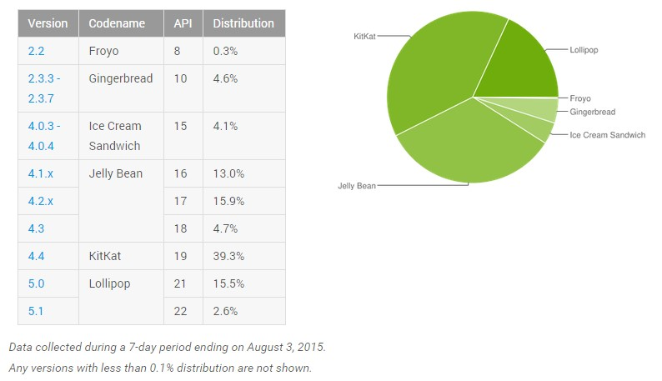

On the basis of the above mentioned statistics we aim to develop our project for all the android mobiles running Android 4.1 or above.

Similarly as per the report by Apple, approx. 79% iOS devices use iOS 10 followed by iOS 9 which share 16% of the market. As a result if the secondary need of the project that is development of iOS application is to be achieved we will be developing the same for iOS devices running version 8 or later.

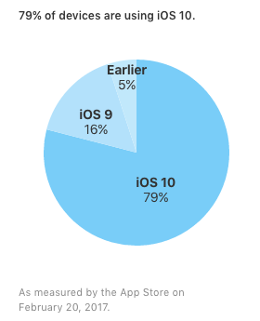

## 5.3 Student skills and Responsibilities

What is each group members experience and skills?

**Introduction :**

Here’s the list of our members along with their UOW details and skills they possess:

|  |  |  |  |  |
| --- | --- | --- | --- | --- |
| Sr. No | Student ID | Name | UOW Mail | Skills Set |
| 1 | 5308057 | Vishal Mishra | Vm816@uowmail.edu.au | Mobile Developer (iOS + Android)  Web Development  Logical and Analytical Reasoning  Presentation and Communication  UI/UX Designer |
| 2 | 5238699 | Jingwang Teh | jt957@uowmail.edu.au | Web Developer  Database Designer  UI/UX Designer  Design Analysis and Reasoning |
| 3 | 5297667 | Christopher Tan Wei Ming | cwmt957@uowmail.edu.au | Business Analyst  Network Analyst  Web Designer  Web Developer |
| 4 | 5275441 | Olawale Adeyinka Adu | oaa692@uowmail.edu.au | Business Analyst  Network Analyst  Photo Editor  Web Designer |
| 5 | 4359999 | Yuxin Deng | yd536@uowmail.edu.au | Business Analyst  Web Designer  Web Developer |

**Initial Responsibility Assignment Matrix**

Legends –

R- Responsible

A- Accountable

C– Consulted

I - Informed

|  |  |  |  |  |  |  |  |
| --- | --- | --- | --- | --- | --- | --- | --- |
| DELIVERABLE | TASKS | Vishal | Jingwang Teh | Chris Tan | Chris Deng | Adu | Dr. Koren Ward |
| 1. Overview idea about the project | * 1. – Business Need |  | A | R |  | R | C , I |
|  | 1.2 – Scope of the Project |  | R | R |  | R | C , I |
|  | 1.3 – Market Analysis |  | A |  |  |  | C , I |
|  | 1.4 – Risk Assessment | R | A |  |  |  | C , I |
|  | 1.5 Project Schedule | A , R | A , R |  | R |  | C , I |
|  | 1.6 Background research about similar products |  |  | R | R | A | C , I |
|  | 1.7 Study of the required technologies | R , C | A, R |  |  |  | C , I |
| 2. Requirement Analysis | 2.1 Functional Requirements | R | R |  |  |  | C , I |
|  | 2.2 Non – Functional Requirements | A | A | R | R |  | C , I |
|  | 2.3 Stakeholder Identification | R, A | R,A | R | R | R | C , I |
|  | 2.4 Risk assessment | R | A |  |  |  | C , I |
|  | 2.5 Work Breakdown Structure | A |  |  | R |  | C , I |
|  | 2.6 – Meeting Minutes | A | A | R | R | R | C , I |
| 3. Design and Implementation | 3.1 Use Case diagrams | R | R |  |  |  | C , I |
|  | 3.2 UI/UX design | R | A | A |  |  | C , I |
|  | 3.3 Web Front Development | A | R | R | R |  | C , I |
|  | 3.4 App Development - Android | R | C , A | C | C | C | C , I |
|  | 3.5 App Development - iOS | R | C ,A | C | C | C | C , I |
|  | 3.6 Requirement Review with implemented system | A |  |  | R | R | C , I |
| 4. Testing | 4.1 Testing of individual module | R | R | C | C |  | C , I |
|  | 4.2 – Testing of whole system |  |  | R | A | R | C , I |
|  | 4.3 – Test reports analysis |  | A |  | R | R | C , I |
|  | 4.4 – Comparing it with the requirements |  | R | A | A | R | C , I |
| 5. Market Planning | 1- Promotion Techniques | A |  |  | R | R | C , I |
|  | 5.2 Analyzing the Outreach | A |  | R |  | R | C , I |

# Appendix

## Stakeholder Analysis

The aim of this project is to develop an electricity, gas or water meter reading system that involves the use of a smartphone to take a photo of the meter and image processing software to extract the meter reading from the photo of the meter. Also having two variants one that will be used by the customer that will provide the customer with his/her utility consumptions, analytical graphs and other billing information as well a version for the meter reading person employed by the utility provider. On the basis of this our key stakeholders are as follows

**Client / Supervisor :** The Project Smartphone Meter Reading System undertaken by our group is supervised by **Dr. Koren Ward.** She remains the key stakeholder for this project as the idea of using the smartphone for meter reading belongs to her, we being the group are accomplishing and implementing the idea as per the requirements and briefings given by **Dr. Koren Ward.**

**Customer :** The aim of this project is to develop an electricity, gas or water meter reading system that involves the use of a smartphone to take a photo of the meter and image processing software to extract the meter reading from the photo of the meter. As a result it is important to consider customer as another important primary stakeholder as customer is the one who will be using the application to carry out the mentioned tasks. Failure to consider the customer as a stakeholder may result in failure of the application

**Utility Service Providers :** Another version of the app will be used by the electricity , gas or water distributor as they employ employee to carry out task of meter reading and then sending the data to the retailers. Ideally the minutes spend by the employee to read a meters is approx. 2 to 3 mins per meter as he is required to enter all the reading manually and then he submits it to the database. Thus the retailer version of the application includes utility service providers like electricity , gas and water distributors as one of the key stakeholder as implementation of the idea / application has an impact on their productivity.

The following matrix provides overview about the mentioned stakeholders and their impacts on the project.

|  |  |  |  |  |  |
| --- | --- | --- | --- | --- | --- |
| ***Stakeholder Name*** | ***Contact Person*** | ***Impact – How much the project impact them?*** | ***What is important to the stake holder?*** | ***How could stakeholder contribute to the project?*** | ***Influence – How much influence they have over the project?*** |
| Client | Dr. Koren Ward | High | The Requirement of the project must meet her expectations.  The application should be reliable , secure , and efficient in use as well as user friendly | By providing feedback and reviewing the implemented ideology and module.   By Providing hints on how to achieve the required task.  By stating the requirements of the system | High |
|  |  |  |  |  |  |
| Customer | Friends , lecturers and group members | Customer Version – High  Retail Version - High | An application which is quality build.  Providing Accurate readings, and having user friendly GUI for ease of use. | By providing feedback on his/her usage.  Providing user experiences about the app.  Reviewing the customer version of the app and providing feedback regarding the changes that need to be done | Customer Version – High  Retail Version - Low |
|  |  |  |  |  |  |
| Utility Service provider | Electricity , Gas and water distributors | Customer Version – Medium  Retail Version - High | Secure connection to the database.  Accurate readings of the meter along with right GPS co-ordinates.  Easy to use and fast processing of the image. | By providing feedback on the app.  By raising certain viewpoint that may be company standard and may not be known to the developer. | Customer Version – Medium  Retail Version - High |
|  |  |  |  |  |  |

## Project Charter

|  |  |  |  |
| --- | --- | --- | --- |
| **Project Title:** Smartphone Meter Reading System | | | |
| **Date of Authorization:** 17th March 2017 | | | |
| **Project Start Date:** 17th March 2017 | | **Project Finish Date:** 27th October 2017 | |
| **Key Schedule Milestones:**   * Complete Business case by 24th March 2017. * Complete Software Requirement Specification (SRS) by 13th April 2017. * Complete and Present Mobile Application & Web Interface Design by 19th May 2017. * Complete Preliminary Website and Planning Documentation by 26th May 2017. * Present Prototype Version of the System by 22nd September 2017. * Finalize Product and Documentation by 20th October 2017. * Present Final Product in Tradeshow for Marketing and Technical Presentation on 27th October 2017. | | | |
| **Budget Information:** There will not be any budget allocated for this project, and any funds required will be taken from group members. The development of this project will be completed by UOW students as the sole human resource, thus, no costs is required for work. There will not be any hardware costs as devices (e.g. energy meter) will be provided for testing and display. | | | |
| **Project Manager:** Vishal Mishra (vm816@uowmail.edu.au) | | | |
| **Project Background:** The process of meter reading is currently expensive and inefficient as energy companies are required to employ a high number of workers to read energy meters manually, making it prone to human errors and slow without the aid of technology. | | | |
| **Project Objectives:**   * Improve efficiency of energy meter reading process. * Reduce cost by requiring fewer workers to read energy meters. * Allow any customer to read energy meters. * Allow customers to look at both the current trend and forecasts of their energy usage. | | | |
| **Main Project Success Criteria:**  By 20 October 2017, implement the smartphone meter reading android application, and website application with resource analytics, and compile all product documentation developed at each project milestones, by adhering to assessment guidelines, requirements requested by client and supervisor, and international standards, and utilizing the currently available computer vision technology and web analytic presentation tools, in order to improve the efficiency of reading meter measurements for employees who are required to repeat the same task for countless homes in NSW, and provide customers with information regarding their current usage and forecasted usage of the resources. | | | |
| **Approach:**   * Hold weekly meeting with supervisor regarding project progress. * Update and refine requirements as we implement and improve the mobile application and web application. * Conduct thorough software testing throughout its development. | | | |
| **Roles and Responsibilities** | | | |
| **Name** | **Role** | **Position** | **Contact Information** |
| Dr. Koren Ward | Supervisor | Supervisor | koren@uow.edu.au |
| Vishal Mishra | Project Manager | Manager | vm816@uowmail.edu.au |
| Jingwang Teh | Team Member | Programmer | jt957@uowmail.edu.au |
| Christopher Tan Wei Ming | Team Member | Programmer | cwmt957@uowmail.edu.au |
| Olawale Adeyinka Adu | Team Member | Programmer | oaa692@uowmail.edu.au |
| Yuxin Deng | Team Member | Programmer | yd536@uowmail.edu.au |
| **Group Procedures & Rules:**   * **Supervisor Meeting Details:**   + When – During consultation time on Friday 12:30pm to 2:30pm   + Where – Building 3.107   + Frequency – Every Week * **Group Meeting Details:**   + When –   + Where –   + Duration –   + Frequency – * **Group Contact Method:**   + Method 1 : Facebook Group Chat   + Method 2 : UOW Email * **Absence (Group Meeting):**   + Margin of lateness : 5 to 15 minutes   + Acceptable Reasons : Emergency or Sick   + Action : Inform others via Facebook Group Chat   + Consequence : 3 Points Warning, once over, treat everyone for lunch, points reset * **Group Participation:**   + Online discussions through Facebook group chat.   + Contribute to documentation on GitHub repositories. * **Lack of Participation:**   + Find out reason for lack of participation   + Give 5 Points Warning   + Report to subject coordinator * **Group Decision Making:**   + Team Leader (for small decisions as primary contact with supervisor)   + Group Vote | | | |
| **Team Goals:**   * Be able to work together as a team with the same mindset and motivation. * To discover new interests and opportunities through project development and learning new technologies. * Develop a final product that everyone can be proud of. * Completing this project and gaining an invaluable experience working together as a group through both the good and bad moments that we can look back to. | | | |
| **Sign-off & Commitment:** | | | |
| **Comments:** | | | |

## Group Meeting Agendas and Minutes

Our group had 3 meetings in the span of the 3 weeks developing our initial business case,

1. 10th March 2017 – This meeting focused on introduction to each other, knowing the strong and weak skill set of each individual member, and later on proceeding with sorting project into categories, selecting categories and prioritizing projects.
2. 17th March , 2017 –This was also our first meeting with our supervisor Dr. Koren ward, explaining to us the main ideology of the project and its functions, and what the product is expected to do, along with giving information about the technology to be used and briefing us about the problems this project aims to solve. The latter half focused on setting up some ground rules for the project and assignment of roles and tasks.
3. 24th March 2017 – After the completion of individual tasks, this meeting focused on reviewing the document produced up until now under the supervision of Dr. Koren Ward and refining it as per the changes asked to do.

**Meeting #1**

**[Friday, 10th March 2017]**

|  |  |  |  |
| --- | --- | --- | --- |
| **Date:** | Friday , 10th March 2017 | **Venue:** | Library Group Study Room 4 |
| **Start:** | 12:30 P.M | **Chair:** | Jingwang Teh |
| **End:** | 2:15 P.M | **Minutes:** | Jingwang Teh |
| **Attendees:** | Vishal Mishra  Jingwang Teh  Chris Tan  Chris Deng  Adu | **Apologies:** |  |

|  |  |  |  |  |  |  |
| --- | --- | --- | --- | --- | --- | --- |
| **No** | **Task / Agenda** | **No** | **Sub-Topic** | **Responsible** | **Duration** | **Outcomes** |
| 1 | Introduction |  |  | Everyone | 30 Minutes | Everyone came to know about each other. The course individual is perusing the weakness and strong skills on possesses and how it can be used in project development. |
| 2 | Project Sorting | 2.1 | Initial Project Grouping | Everyone | 50 minutes | All the project that was displayed on Moodle was studied.   Based on the technologies and platform it need to be developed for the project was grouped into number of categories example Web Based projects , Mobile App based projects and so on |
|  |  | 2.2 | Project Selection | Everyone | 15 minutes | Based on the Skills sets of the members in the group the categories were selected.  Later Specific Projects was selected that our group thought is achievable on the basis of the skills we have. |
|  |  | 2.3 | Project Priority Setting | Jingwang Teh | 10 Minutes | After few of the projects were selected there was a voting that was done to select the top three projects and then the selected one were set up in project selection sheet based on the innovation level, and skills required. |

**Meeting #2 (Initial Meeting with Supervisor)**

**[Friday, 17th March 2017]**

|  |  |  |  |
| --- | --- | --- | --- |
| **Date:** | Friday , 17th March , 2017 | **Venue:** | Building 3 - Front Sitting Area |
| **Start:** | 12:30 P.M | **Chair:** |  |
| **End:** | 2:30 P.M | **Minutes:** | Vishal |
| **Attendees:** | Vishal Mishra  Jingwang Teh  Chris Tan  Chris Deng | **Apologies:** | Adu |

|  |  |  |  |  |  |  |
| --- | --- | --- | --- | --- | --- | --- |
| **No** | **Task / Agenda** | **No** | **Sub-Topic** | **Responsible** | **Duration** | **Outcomes** |
| 1 | Project Explanation | 1.1 | Project Explanation by Dr. Koren Ward | Everyone | 48 Minutes | This was our first meeting with Dr. Koren Ward. She Explained the project to all of us briefly and explained how the underlined tasks can be achieved.  After the explanation she displayed few examples of the meter that is available, explaining the background about the problems why this application (Smartphone meter reading) is needed.  She then explained us the technologies that we can use and told us how we can use those and implement the project. |
| 2 | Project Description Note-down | 2.1 | Initial Requirements | Everyone | 40 minutes | Based on the explanation from Dr. Koren Ward we created a rough draft of what exactly our project is intended to be (Rough Requirement list)  We then went further with the breakdown of the requirements and also analyzed the first assignment and distributed the roles and responsibilities to individual. |
|  |  | 2.2 | Role Assignment | Jingwang Teh and Vishal | After analyzing the project based on the skills our group possessed roles were assigned to individual on the basis of the strong skill set one had |
|  |  | 2.3 | Assignment Work task allotment | Jingwang Teh and Vishal | As the assignment due was almost around the corner documentation tasks based on the A1 template on Moodle was assigned to individual. |
| 3 | Planning And Activities’ | 3.1 | Source Control | Chris Deng | To have consistency and knowledge about other members’ work, Git was decided to be our source control program |
|  |  | 3.2 | Communication platform | Chris Tan | Facebook was decided to be used as general communication platform. |

**Action Items**

|  |  |  |  |  |
| --- | --- | --- | --- | --- |
| **No** | **Item** | **Responsible** | **Deadline** | **Comment** |
| 1 | Setting up Git Account , Facebook group | Adu | 17th March 2017 , 10 P.M | Completed on time |
| 2 | Completing the task allotted to them related to Assignment 1 | Everyone | By next Meeting | Completed on time |

**Meeting #3**

**[Friday, 24th March 2017]**

|  |  |  |  |
| --- | --- | --- | --- |
| **Date:** | Friday , 24th March, 2017 | **Venue:** | Building 3 - Front Sitting Area |
| **Start:** | 2:30 P.M | **Chair:** |  |
| **End:** | 3:45 P.M | **Minutes:** |  |
| **Attendees:** | Vishal Mishra  Jingwang Teh  Chris Tan  Chris Deng  Adu | **Apologies:** |  |

|  |  |  |  |  |  |  |
| --- | --- | --- | --- | --- | --- | --- |
| **No** | **Task / Agenda** | **No** | **Sub-Topic** | **Responsible** | **Duration** | **Outcomes** |
| 1 | Report review with the Supervisor – Dr. Koren Ward |  |  | Everyone | 30 Minutes | Everyone showed the part of work they did ranging from Scope of the project to the stakeholder analysis also the structure of the Agenda to the supervisor.  She reviewed and pointed out the necessary minor changes that was mandatory and asked to make the changes. |
| 2 | Refinement |  |  | Everyone | 50 minutes | Based on the review our group over the project report we made the necessary changes to our project report for assignment 1.  We then compiled everything together and checked it again for spelling and grammar mistakes. |

**Action Items**

|  |  |  |  |  |
| --- | --- | --- | --- | --- |
| **No** | **Item** | **Responsible** | **Deadline** | **Comment** |
| 1 | Designing up the interface for the project application | Vishal and Jingwang Teh | By Next meeting |  |
| 2 | Study of OpenCV and its integration with the Android Platform | Chris Tan and Adu | By next Meeting |  |
| 3 | Based on the initial rough list of the requirement we understood based on our first meeting with the supervisor, creation of Functional and Non function requirements | Adu | By next Meeting |  |